Testing
Introduction to the Test Plan Pro Forma

Testing 1
Errors are good! 1
When to Test 3
Why do we test? 3
What do we test? 3
System Testing 4
Is your code correct? 4
Black Box Testing 4
Completing the Test Plan & Log 4
Description of Item to be Tested 5
Extreme Min(imum) 5
Min (Boundary) 6
Max (Boundary) 7
Mid 7
Extreme Max 8
Invalid Data Type 9
Other Tests 10

Testing
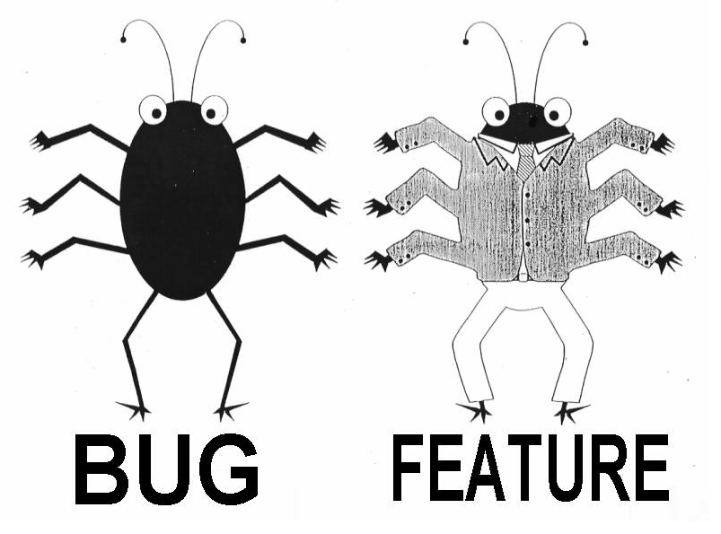
Testing is a very big and important topic when it comes to software development.
Testing has a number of aspects that need to be considered.
- System stability – is the system going to crash or not?
- System usability – is the system easy to use?
- System security – is the data and code safe from hackers?
Testing will never be the most exciting task in the world however it is one of the most important when it comes to programming.

Errors are good!
The first thing that I want to say about testing is that errors are good.
I do not know a single person who doesn’t make mistakes especially mistakes when creating computer based applications.
If you create a system and tell me that you tested it and found no problems I simply won’t believe you.
There is always something wrong with your work at some point in the design.
If it isn’t an actual fault then there will always be something that could have been done better.
We test to find errors and they will exist, therefore we need to find them!
In documenting your testing I expect you to state clearly what errors you found and what you did about them in your test logs.
If you have tests with no errors and no resulting changes to your system, your test strategy is simply flawed.

Why do we test?
The most obvious reason to test your site is to find faults or errors with the code. Bugs need resolving before the application goes live.
However, because the suitability of our systems may be open to interpretation we need to be very careful that our design is suitable for the user.
You may create an interface that looks perfectly fine to you as the developer however it fails when placed in front of the customer.
Why is this?
One problem is that as the author of your system you know it back to front. You know where everything is and what buttons to press to perform different tasks. You will inevitably be an expert on your own design and as a result find it hard to imagine what it is like to approach your design for the first time.
We need to have our designs viewed through fresh eyes to see the things that are hard to see ourselves.

What do we test?
We need to test the code that makes up our system however we also need to test other aspects of the system too that may be harder to identify than a broken link.
For example we need to find some way of answering the question does our system provide “ease of use”?
For this lecture I shall concentrate on system testing.

System Testing
There are a number of issues that need to be considered under the heading of system testing.
You will need to consider issues such as the following.
- What happens when bad data is entered?
- Do all of the links to pages work?
- Does your design work on different browsers?
- Does your design work at different screen resolutions?
- How does your design behave on different computer platforms?

Is your code correct?
Even though we have no code in place we may still create tests that may be applied as soon as the code is written. This approach to testing sees the system as a black box. We don’t care how the code works, but we do know what values should / shouldn’t be accepted even at the early stages.
The thing about testing is that the numbers of inputs to our system are potentially infinite. We are not in a position to anticipate every permutation. To get around this we need to plan our testing to concentrate on significant points in the data.

Completing the Test Plan & Log
You have been provided with a standard format for test plans / logs which you need to learn how to complete.
Below is the layout for the test plan & log…
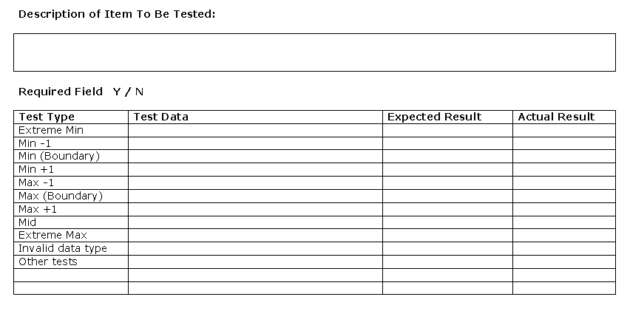
The pro forma is available for download from the main web site.
The following example will assume that there is a field on a web form for entering the age of a staff member.

Description of Item to be Tested
This should contain a brief description of the field in question under test.
e.g.
“Age field for staff member.”

Extreme Min(imum)
The Extreme Min is an example of an excessively small value for the field. This may never be input under normal circumstances however it is important to test your application for unexpected situations.
An extreme minimum in the case of a person’s age might be any value in minus figures e.g. -300
Test Type | Test Data
Extreme Min | -300
Min -1
Min (Boundary)
Min +1
Max -1
Max (Boundary)
Max +1
Mid
Extreme Max
Invalid data type
Other tests

Min (Boundary)
The Min (Boundary) test data is the smallest acceptable value for the field.
In the case of the age the smallest acceptable value may be zero, or it may be another value such as 16 depending on the rules for the circumstance.
In this case we shall assume that the smallest acceptable value is 13 as this is the youngest age legally allowable. Based on this we may generate test data for the Min -1 and Min +1 values.
Test Type | Test Data
Extreme Min | -300
Min -1 | 12
Min (Boundary) | 13
Min +1 | 14
Max -1
Max (Boundary)
Max +1
Mid
Extreme Max
Invalid data type
Other tests

This is referred to as a boundary test as it tests the minimum acceptable value and either side of that boundary.

Max (Boundary)
The Max (Boundary) is the maximum allowable value for the field. We could specify some arbitrary figure such as 150 however there is such a thing as a retirement age (currently 65) however workers do have an option to work for longer, in this case we shall set the age max to a semi arbitrary 80.
Test Type | Test Data
Extreme Min | -300
Min -1 | 12
Min (Boundary) | 13
Min +1 | 14
Max -1 | 79
Max (Boundary) | 80
Max +1 | 81
Mid
Extreme Max
Invalid data type
Other tests

Again this allows us to generate the -1 and +1 values.

Mid
The mid range value is a value half way between the Max and Min boundary values. Min = 13 Max = 80 therefore Mid = 47.
Test Type | Test Data
Extreme Min | -300
Min -1 | 12
Min (Boundary) | 13
Min +1 | 14
Max -1 | 79
Max (Boundary) | 80
Max +1 | 81
Mid | 47
Extreme Max
Invalid data type
Other tests

Extreme Max
This is an extremely large value that hopefully may never occur e.g. +300
Test Type | Test Data
Extreme Min | -300
Min -1 | 12
Min (Boundary) | 13
Min +1 | 14
Max -1 | 79
Max (Boundary) | 80
Max +1 | 81
Mid | 47
Extreme Max | 300
Invalid data type
Other tests

Invalid Data Type
In this example of age, the data type is an integer value. We need to generate a few values which are inappropriate for the integer data type e.g.
String “Fred”
Date 01/01/2001
Decimal 14.5

Test Type | Test Data
Extreme Min | -300
Min -1 | 12
Min (Boundary) | 13
Min +1 | 14
Max -1 | 79
Max (Boundary) | 80
Max +1 | 81
Mid | 47
Extreme Max | 300
Invalid data type | Fred
 | 01/01/2001
 | 14.5
Other tests | Anything else you can think of

Other Tests
This relates to any other testing that you can possibly think of. Should the field be a required field then it will be a good idea to test what happens should the field be left blank.
Once the test data for that field has been compiled, one should then move on to other fields within the program.
Once all of the test data has been assembled the tests should be run and the test plan & log annotated indicating the results of the test.
Should any test conditions not run as expected then the developer must be notified in order to debug and correct the code.

Handling Specific Data Types
One thing you will soon discover as you create this page is that entering incorrect data will result in the system crashing.
Rather than a crash what we really is for the system to provide an error message and allow the user to correct the error.

Test Plan Procedure
In creating the test plan we shall always follow these steps even if we decide they don’t matter for the data type in question…
- Always Start with Min and Max Tests
- Next Work out Boundaries
- Extreme Maximum and Extreme Minimum
- Test the Mid Range
- Test Invalid Data Type
- Complete Other Tests
- Complete Expected Result
- Complete Additional Notes/Instructions

Starting With the Data Layer
A good place to begin is with the data layer (this may currently only exist on paper). The data layer gives us some useful clues as to what the rules are for the data we are using.
Look at the table definition for tblWidget to inspect the table’s design and properties.
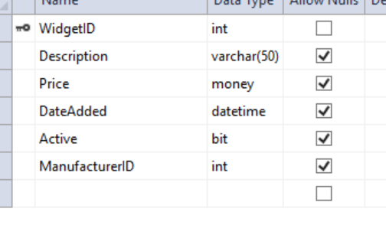
For example Description is defined as varchar(50) which means the maximum size is 50 characters.
Also note the data types for each field.
Once you have done that close the table definition think about the fields on the main data entry form…
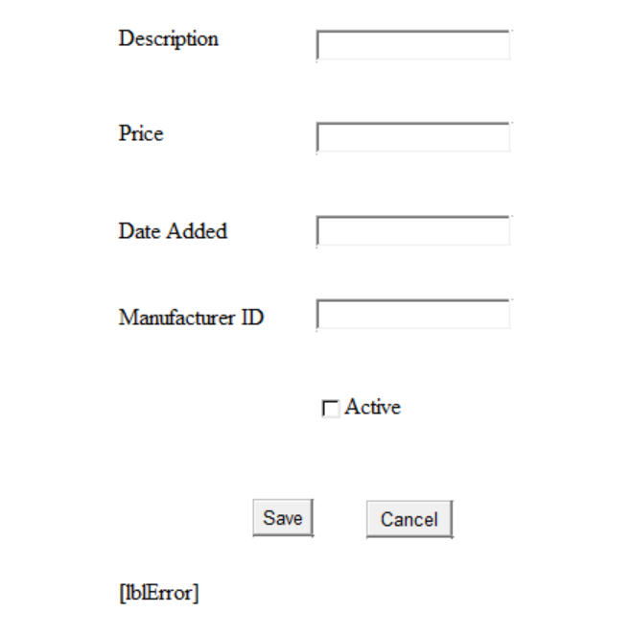
The next step to make a note of which fields must be completed and which ones may be left blank.
In this case…
- Description Required
- Price Required
- DateAdded Required
- ManufacturerID Required

Once you have all of this information you may start writing your test plan.

The Test Plan
Once we have given some thought to the nature of our data we may have a go at completing the test plan.
The test plan structure is as follows and may be obtained from the module web site…
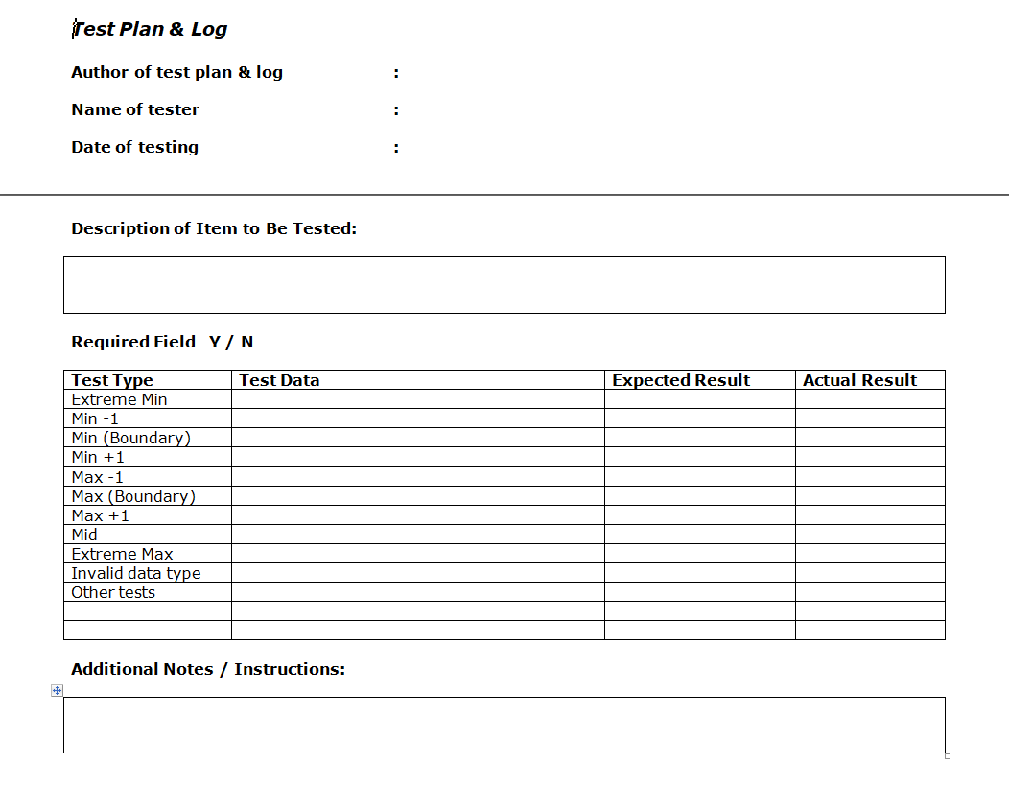
The document has various sections that need completing.
The first item to complete is the name of the author of the test plan…
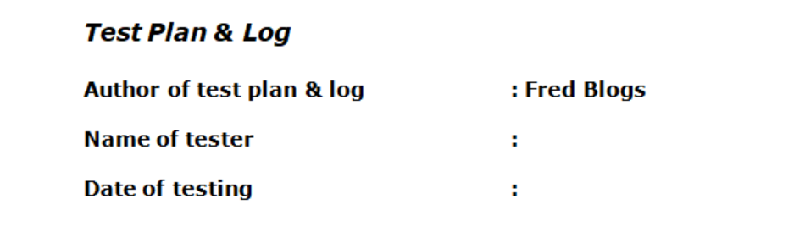
As a student the author of the plan and the person carrying out the testing are likely to be the same person. In reality they are most likely to be two different people. For the moment just complete the Author’s name. We shall complete the other two items later on when we actually run the test.

Testing Description varchar(50)/string
We will now go through the testing for the field Description.
The first thing to do is complete a description of what the field does. Given that in real life the person who writes the test may not be the same person who carries out the test it is a good idea to give some appropriate details here.
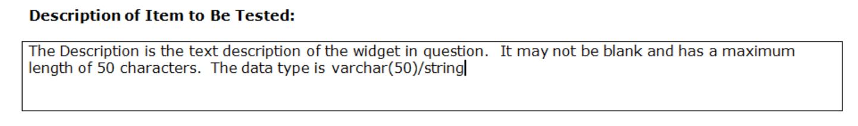
The next section to complete is to explicitly state that this is a required field. The answer to this question will determine how we write the individual tests for the attribute…
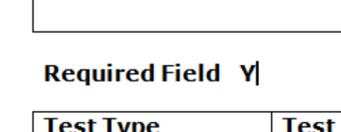
In this case Description may not be left blank so we need to delete the N and make sure Y is indicated.
We now need to think about how to complete the individual test cases for the field…
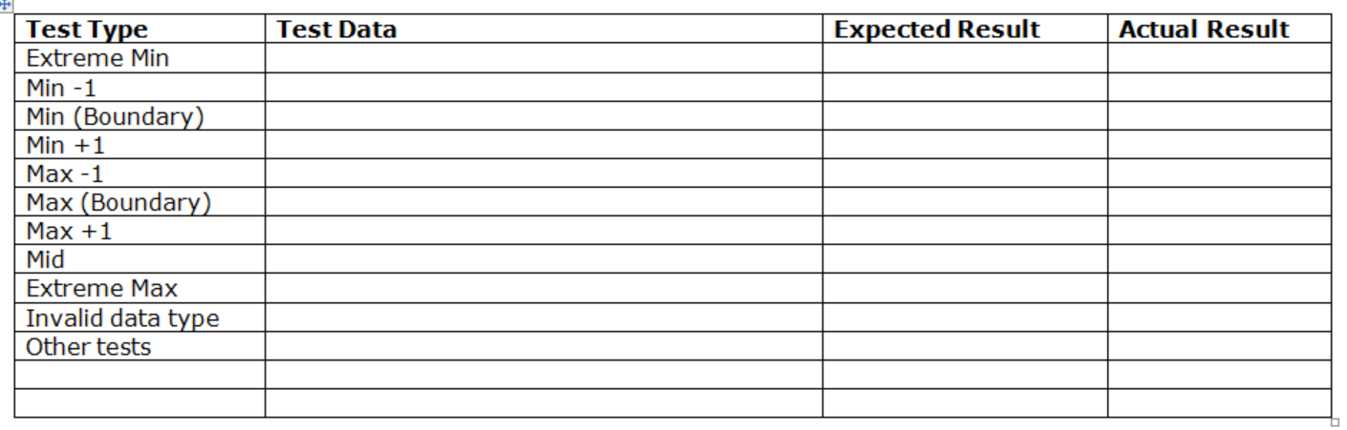
Although there are potentially 11 test cases to consider here, we may not have to complete them all. How many we complete varies depending on the data type in question. We shall see some examples of this as we proceed.

Always Start with Min and Max Tests
For any data type always think about what are the smallest allowable value and also the largest allowable value?
Be careful as these values vary depending on the data type.
For example a string value like Description we would likely look at the smallest and largest number of characters.
In the case of a price we wouldn’t care about the number of characters but we would care about the lowest and highest price.
In the case of dates we might consider the earliest and latest dates.
In the case of Description we would go with the following test data for min and max…
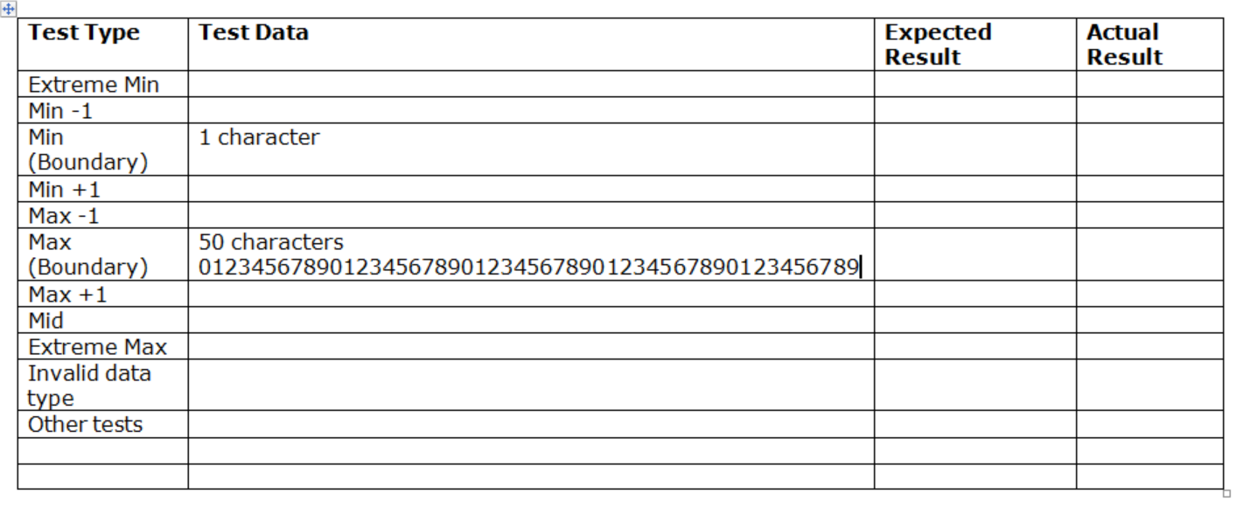
Given that we are stating that the field must be completed then we are going with a minimum of 1 character.
Based on the setting for the field in the database…
Description is set to varchar(50) so the maximum number of characters is 50.
Notice the little trick in creating 50 characters of test data.
If you quickly create a string on the keyboard “0123456789” we know that this is 10 characters. If we copy and paste the string we quickly generate 50 characters – “01234567890123456789012345678901234567890123456789”
As well as stating how many characters we need to deal with it is a good idea to explicitly state what the test data actually looks like…
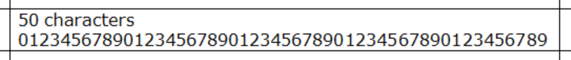

Next Work out Boundaries
Once we know the largest and smallest values we may work out what the boundaries are…
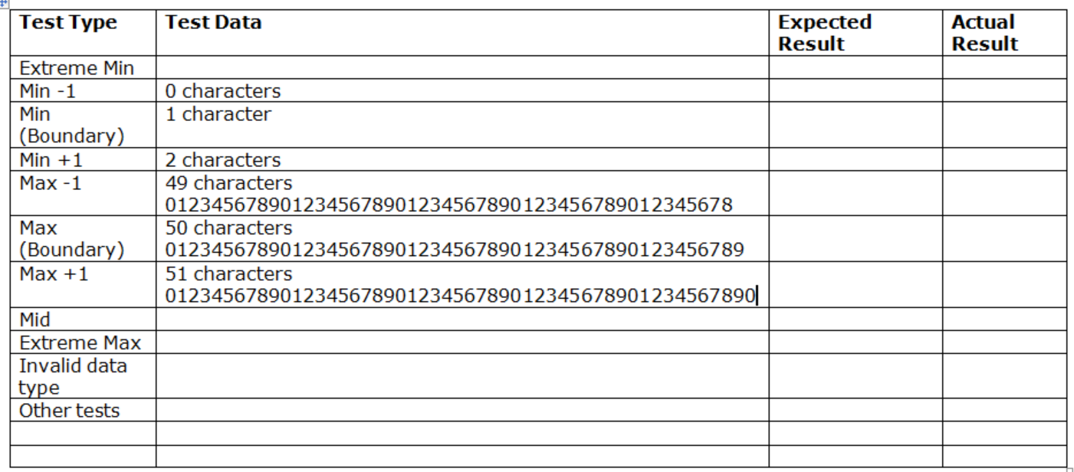
- Min less one takes us to zero characters (a blank string)
- Min plus one gives us two characters
- Max less one gives us 49
- Max plus one 50

Now we have the boundaries we need to work out the extreme maximum and the extreme minimum.

Extreme Maximum and Extreme Minimum
In the case of these two tests we come up with the following…
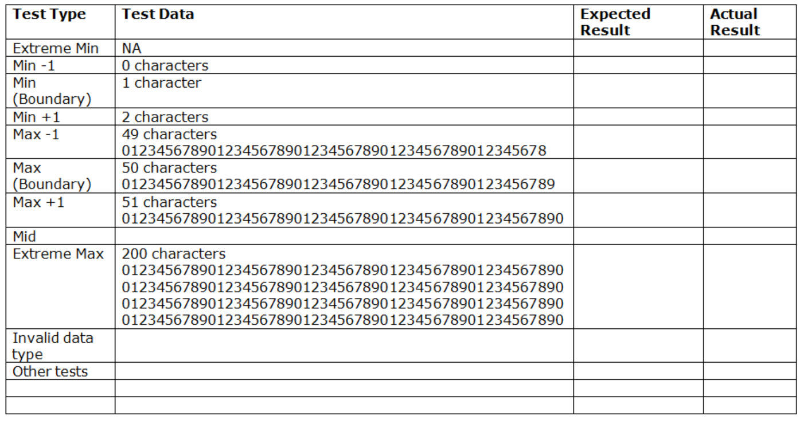
Since in the case of extreme minimum we would have to enter negative number of characters (which is impossible) we mark the test as NA (Non Applicable). This is an example of a test being inappropriate for the data type in question.
Also notice how we have used copy and paste to generate 200 characters.

Test the Mid Range
Once we know the above tests we may test the mid way between maximum and minimum, in this case 25 characters…
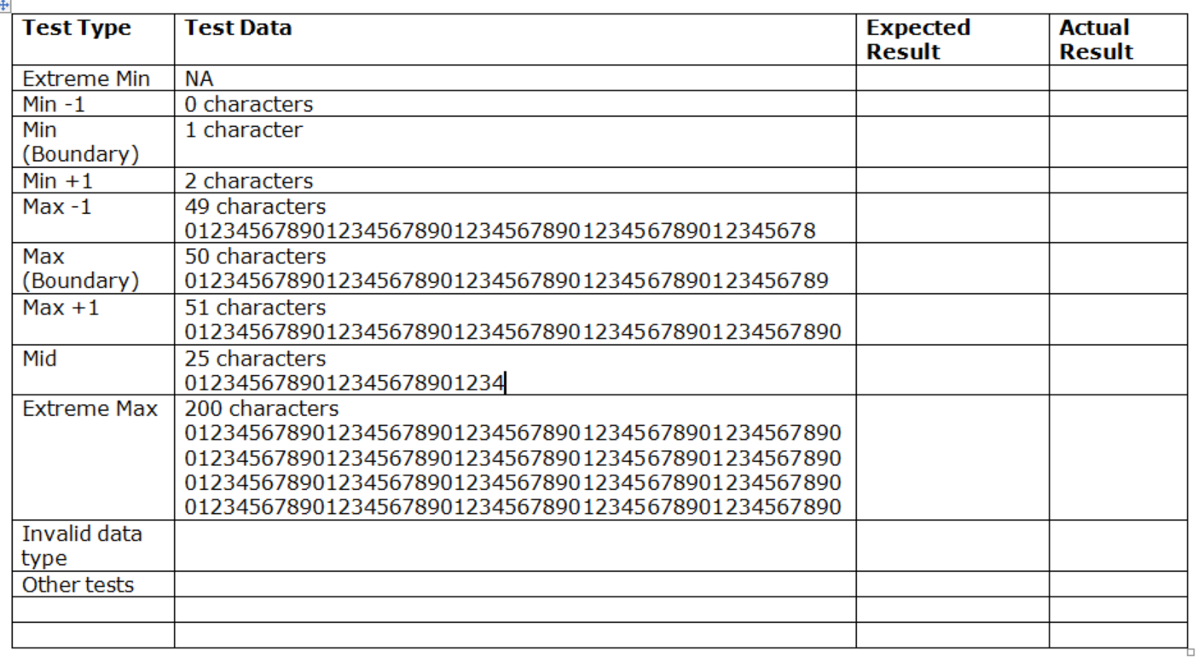

Test Invalid Data Type
In the case of a string it is hard to come up with invalid data that it won’t deal with. That being the case we shall also mark this as NA…
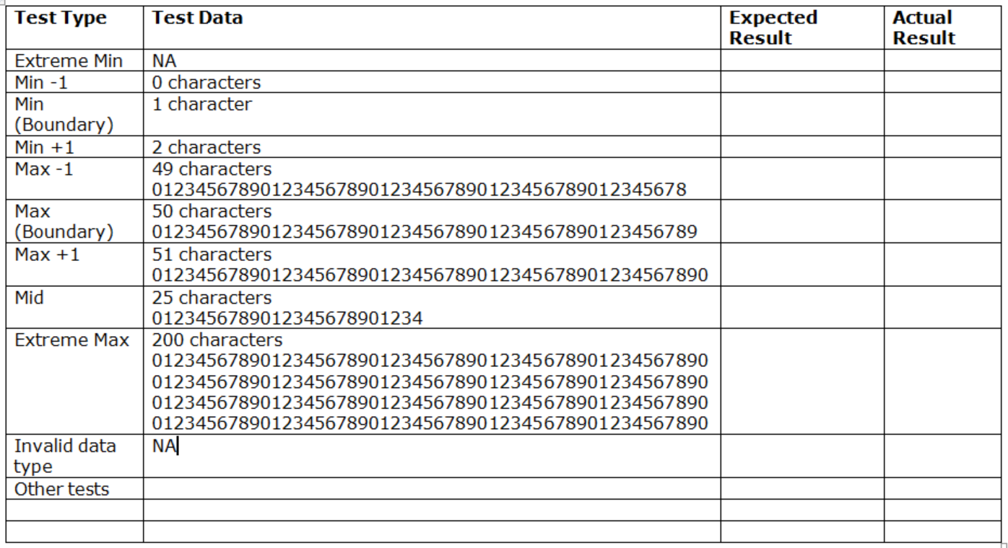

Complete Other Tests
The last test to generate is “other tests”. An example of an “other test” is if having completed this field in some way we have to also complete a second field. We shall mark this as NA too…
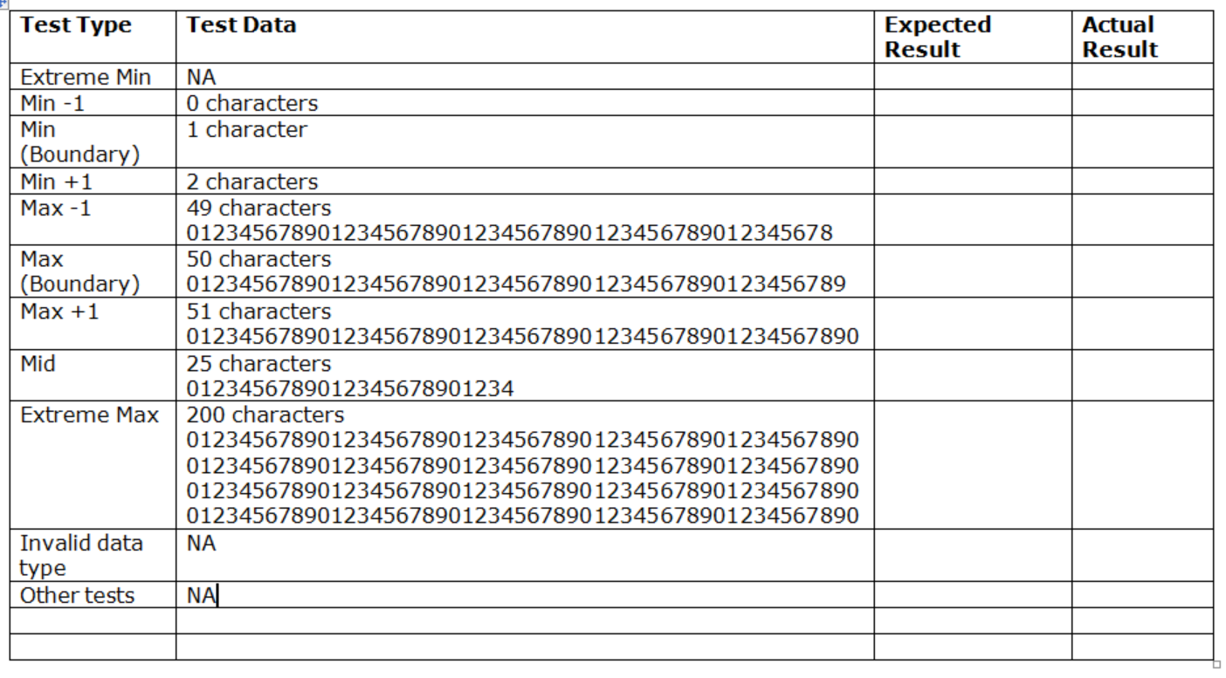

Complete Additional Notes/Instructions
There may be some additional comments you want to include for the tester. If not leave this blank.

Complete Expected Result
Once we have the test data we may now complete the column for expected result.
What we are stating here is if the test data in question should trigger an error or of it will be accepted by the system…
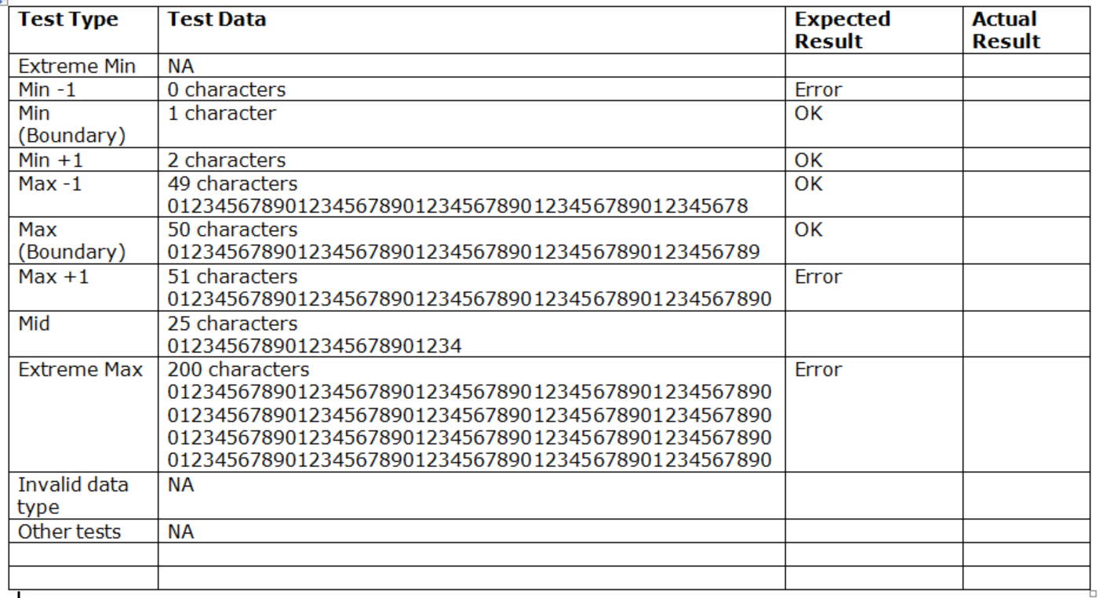
The last field to complete is the actual result. The problem is that we cannot complete this until the system has been written!
Let’s do another example…

Price money/decimal
Here is my test data…
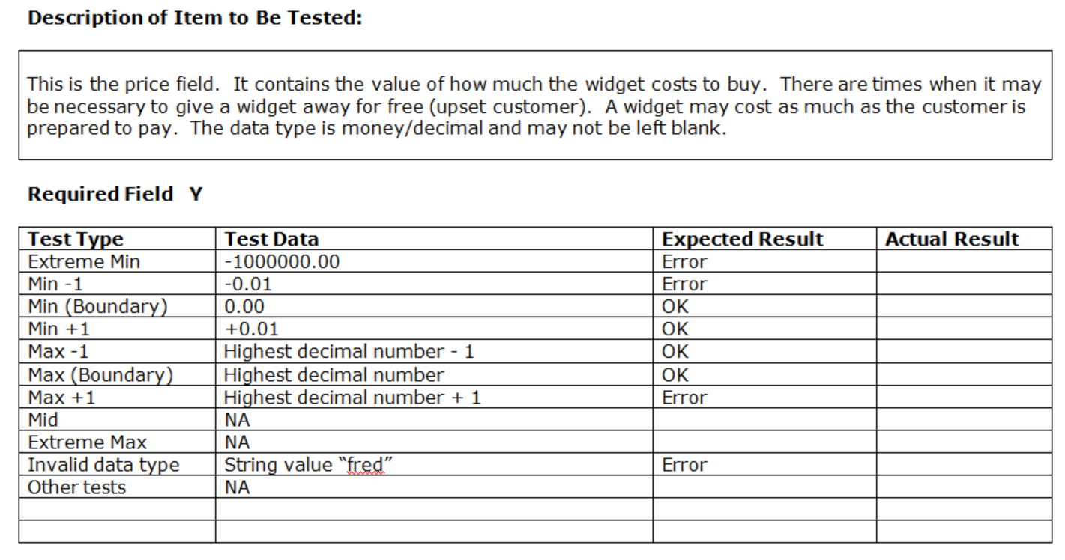
Here are some things to think about on the matter of price.
In the case of the minimum value it is likely wise to set this as zero. In most systems a non-zero value item here means that you cannot give away free gifts for example to a very angry customer.
Notice that we a numeric field we can state a value for extreme min, in this case minus 1 million pounds.
One issue here is the question “what is the maximum value?”
We “could” say that the maximum is £1,000,000 but what if a customer wanted to pay more? Would we turn them away?
We could say that the maximum value in infinity, but it isn’t.
In the case of all numeric data types there is a number that exists which will be too big to store and will crash the computer.
In the case of decimal it is the stupidly large number…
(I believe 2 raised to the power of 96)
2000000000000000000000000000000000000000000000000000000000000000000000000000000000000000000000000
We shall refer to this value as MaxDecimal.
So how might we test for this?
When we come to writing the code we will use try and catch like so…
try //try to convert the data
{
//declare a temp variable to store the value
decimal TempPrice;
//try a type conversion on the original data
TempPrice = Convert.ToDecimal(Price);
}
catch //if the conversion fails the catch will be triggered
{
//generate the error message here
ErrorMessage = ErrorMessage + " Price is not valid, ";
}
In this case we accept the test data as a string, say MaxDecimal + 1
We know that MaxDecimal + 1 should trigger an error.
So when the following line tries to convert the string value to a decimal…
//try a type conversion on the original data
TempPrice = Convert.ToDecimal(Price);

It generates and error and the catch section of try and catch triggers an error.
catch //if the conversion fails the catch will be triggered
{
//generate the error message here
ErrorMessage = ErrorMessage + " Price is not valid, ";
}
The nice thing about this section of code is that it will be used to detect all instances of bad decimal data entered by the user.
Lastly notice that I didn’t bother testing the mid to avoid working out what the mid range is between zero and MaxDecimal! If we can test for a valid number and the max and min then I am going to bet that all other values will be fine.

DateAdded DateTime/Date
Dates can be fiddly things to figure out the test cases for but the procedure is the same as other data types.
- Always Start with Min and Max Tests
- Next Work out Boundaries
- Extreme Maximum and Extreme Minimum
- Test the Mid Range
- Test Invalid Data Type
- Complete Other Tests
- Complete Expected Result
- Complete Additional Notes/Instructions

Here is my test data for DateAdded…
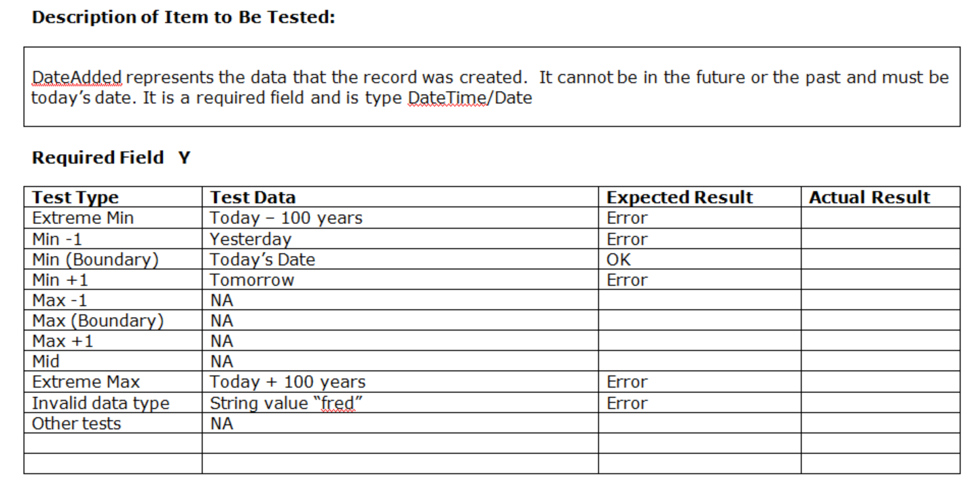
Again some comments.
If we are saying that DateAdded must be today then we hit an interesting situation.
Look at the min and max values, both end up being today..
- Min today
- Max today

Now work out the less one plus one values…
- Min less one yesterday
- Min today
- Min plus one tomorrow
- Max less one yesterday
- Max today
- Max plus one tomorrow

We can work out extreme min and max…
- Extreme min today less 100 years
- Min less one yesterday
- Min today
- Min plus one tomorrow
- Max less one yesterday
- Max today
- Max plus one tomorrow
- Extreme max today plus 100 years

We can’t work out the mid since that is mid way between today and today which is still today!
When we look at the tests we have so far there is quite a lot of duplication so we may abandon most of the tests resulting in these as the important test cases…
- Extreme min today less 100 years
- Min less one yesterday
- Min today
- Min plus one tomorrow
- Extreme max today plus 100 years

Lastly notice how I have not specified an actual date in the test data. I have gone with generic words like today and yesterday.
The thing to keep in mind with testing dates is that the data is date sensitive.
If we state actual dates then they may be OK for the day written but the following day the data will be out of date.

Testing for ManufacturerID Integer
Here is one last example to complete the set…
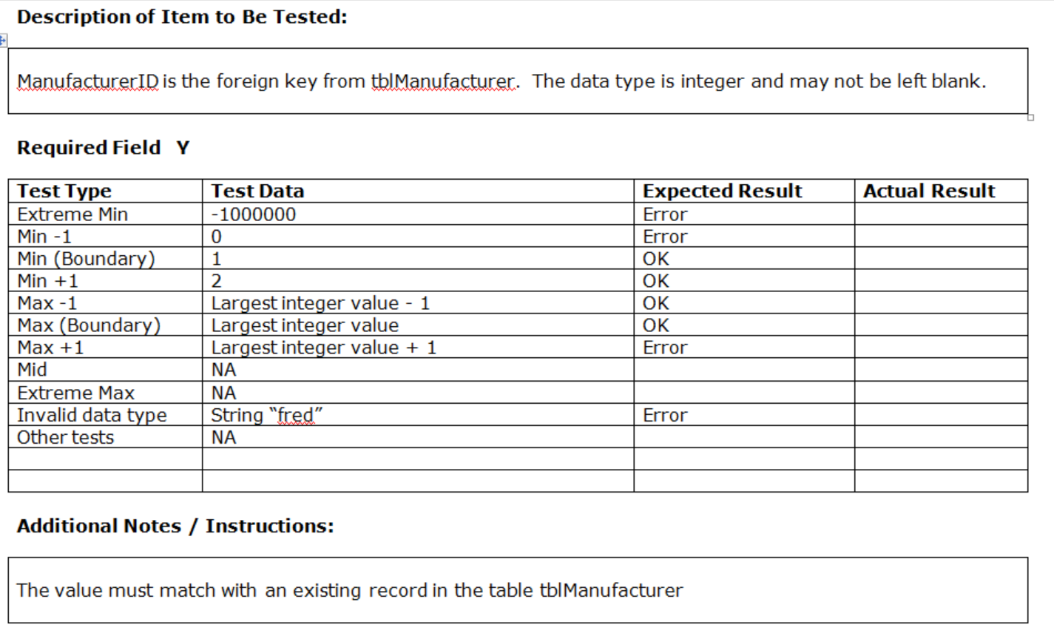
The test data shares similar issues with a decimal field.
Notice though that we have some notes associated with this field. Given that this is a foreign key we also need to make sure that it matches the value of an existing record in tblManufacturer.

Test Driven Development
Test Driven Development (TDD) is an approach to software construction which starts with the test for a feature before the feature even exists.
The rules are…
- Create a test that fails
- Run the test and see it fail
- Fix the error in a simplistic way
- See the test pass
- Re-factor to implement the feature correctly

In TDD rather than starting to write the system without any plan or strategy we take small steps which when added together eventually build in to the finished system.
As we create our tests we will create test cases in our code. Every time we run the system all of the test cases are run against our code and we may be reasonably sure that our system is robust due to the constant application of the test cases.
If at some point we get something wrong the testing will tell us that a test has failed and it should give us a clear indication as to what test has failed and where in the system the problem is.
TDD is a good way of not only building confidence in the systems we create it will also help to build confidence in our own ability as developers.
TDD forces us to take lots of small steps in developing the system and small steps are much easier to cope with than making fewer large steps.

Creating the Test Class
Each of you should have their allocated section of the system. In this example we will work through a widget related example, in your case it will be something else for example...
- Customer management – find customer
- Staff management – find staff member
- Product management – find product
- Order management – find order
The name of the entity to managed changes but the general rules remain the same.
In this example we will look at the method find widget to build this we will start by creating a test class rather than diving in and creating the code directly.

Finally
It is hard to write an exhaustive list of test examples as your rules are likely to be unique to your system.
Having said that always start work through the following steps and discount any test cases that do not apply…
- Always Start with Min and Max Tests
- Next Work out Boundaries
- Extreme Maximum and Extreme Minimum
- Test the Mid Range
- Test Invalid Data Type
- Complete Other Tests
- Complete Expected Result
- Complete Additional Notes/Instructions

